**Website 2018: (TNH)**

Ex: <https://colorlib.com/preview/#civic>

[http://phydeve.epizy.com/ imozar/index-1.html](http://phydeve.epizy.com/imozar/index-1.html)

1. What’s included:

Resume:

* Work exp
* Education
* Personal achievement

Accomplishments:

* Articles

Skills:

* Skill sets (Can he divide his skills into sets?)

Sample of work:

* What kind of work you do
* Show cases

References:

* Testimonies

Clients opinion:

Contacts:

* No social

1. Typography:

* Consider:

+ Visual hierarchy

+ What’s important, what’s needed to be read first.

Helvatica . Stick to this one, changes for later (Needs considerations)

The point of your portfolio is to make you stand out, and it’s hard to stand out as a student using the world’s most generic typeface.

1. Color Schemes:
2. Orange:

* Friendliness, enthusiasm, creativity

1. Blue:

* Trust, security, stability, peace, calmness.

1. Gray:

* Neutral, simplicity, futuristic, logic.

For more info: <https://www.websitebuilderexpert.com/wp-content/uploads/2016/03/Gender-of-color-infographic-by-Kissmetrics.png>

Debate:

Java is mainly used for high level security compare to PHP Programming.

Java server is costly compare to PHP based server.

* PHP is more simple and easy?

**Best Practices for Law Firm Websites**

Good design is the foundation of a website that brings in business. Here’s are the best practices we have identified over the years:

[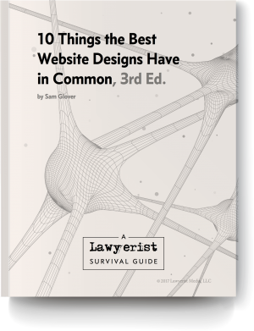](https://lawyerist.com/product/law-firm-website-design-guide/)

1. Start with a well defined goal.
2. Highlight your call to action.
3. Focus on your client-centered value proposition.
4. Welcome mobile devices with responsive design.
5. Avoid visual clutter.
6. Use bold colors and striking images.
7. Take advantage of typography.
8. Design for accessibility.
9. Optimize for search engines.

Secure your website.

Make responsive